West Indian Weevil
Jan 2016.
Notes from internet, compiled by Dave Askin – but acknowledgements below.
Scientific Name: Euscepes postfasciatus Fairmaire

Taxonomy
Class | Insecta
Order | Coleoptera
Family | Curculionidae
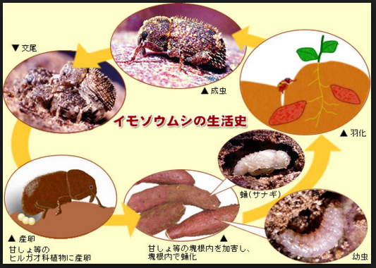
http://blog.livedoor.jp/touxia-plant/archives/1370692.html (in Chinese?)

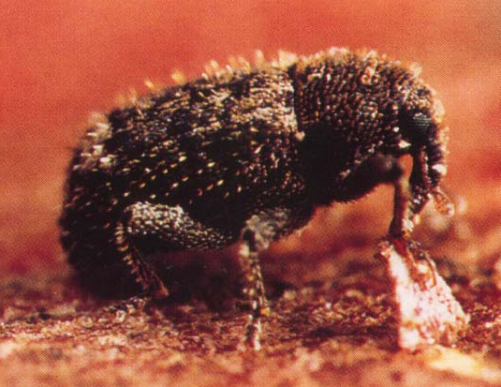 Size????
http://keys.lucidcentral.org/keys/sweetpotato/key/Sweetpotato%20Diagnotes/Media/Html/TheProblems/Pest-Root&StemInsects/WestIndianSPWeevil/WestIndianWeevil.htm

Economic importance
Euscepes postfasciatus rivals the common sweetpotato weevil, Cylas formicarius as the most important pest of sweetpotato in the Caribbean and Central America. Damage is similar to that caused by Cylas formicarius.

Geographical distribution
The West Indian sweetpotato weevil is present throughout sweetpotato-producing regions of the Americas, and in Japan, where an eradication program is currently underway. No published reports have been found of its presence elsewhere.

Damage
The adult weevils feed within vines and storage roots, and the larvae cause most damage by tunnelling within the storage roots. The damage is characterized by small feeding and ovipositional punctures on the surface and larval tunnels filled with frass throughout the flesh of the storage roots. The weevil induces the roots to produce terpenes, giving them a bitter taste and unpleasant odour, so that even partly damaged roots are unfit for human and animal consumption.

Morphology
Egg. The ovoid eggs are yellow to greyish yellow, and laid singly in shallow cavities in the storage roots, and covered with a faecal plug. They are similar in size to those of other sweetpotato weevils.
Larva. The white larvae are legless and less than 1 cm in length.
Pupa. The pupae are creamy white and found within the tunnels in roots and stems.
Adult. The adult weevil is reddish brown to near black, with a compact body covered with short bristles, which are arranged in parallel rows on the abdomen. The head is small and protrudes little from the thorax except for a prominent, downward-curving snout.

Biology and ecology
All sweetpotato weevil species have a similar life history. The adult female lays eggs singly in cavities excavated in vines or in storage roots, preferring the latter. The egg cavity is sealed with a protective, grey fecal plug. The developing larvae tunnel in the vine base or storage root. Pupation takes place within the larval tunnels. A few days after exclusion, the adult emerges from the vine or storage root. Because the female cannot dig, she finds storage roots in which to lay her eggs by entering through soil cracks.
Hot, dry weather favours weevil development. At optimal temperatures of 27-30ºC, C. formicarius completes development (from egg to adult) in about 33 days. Adult longevity is about 75-105 days and females lay between 100 and 250 eggs in this period. At suboptimal temperatures, development takes longer.

Detection and inspection
Detection of early infestation is difficult as adults are most active by night. Early detection can be done by checking the base of the plant for feeding punctures and exit holes. When damage has been detected, several plants could be dug up to establish an idea of the damage level to the roots. This could lead to the decision for an early harvest.
As no sex pheromone is available for this species, pheromone traps can not be used to evaluate the weevil populations. Recently, green light-emitting-diode (LED) traps and pitfall traps have been used successfully to monitor this species.

Host range
Wild species of Ipomoea are important host plants.

Management
When sweetpotato weevil populations are high, no single control method provides adequate protection. The integration of different techniques (IPM) , with emphasis on the prevention of infestation, provides sustainable protection.
Cultural control
Cultural control practices have proven to be effective against the sweetpotato weevil and should be the main basis of control. The local growing conditions and the use of the crop (commercial or for own consumption) will indicate which practices should be applied.
- Sanitation and use of uninfested vine tips as planting material.
- Crop rotation.
- Timely planting and prompt harvesting to avoid a dry period.
- Hilling-up of soil around the base of plants and filling of soil cracks.
- Applying sufficient irrigation to prevent or reduce soil cracking.
- (Sex pheromone traps are species-specific, and have not been developed for E. postfasciatus).
Chemical control
Dipping planting material in a solution of an insecticide (such as carbofuran or diazinon) for 10-15 minutes prior to planting can control sweetpotato weevils for the first few months of the growing season. Dipping longer than necessary can burn and kill the planting materials. Spraying insectides after planting is not (cost)-effective.
Host resistance
Cultivars with immunity or a high level of resistance are not available. Some cultivars have been shown to be less attractive to West Indian weevils in free-choice tests for feeding and oviposition. However, whether this can be equated to less damage in the field has not been demonstrated. Early maturing and deeply rooted varieties expectedly get less weevil damage and can even escape weevil infestation.
Biological control

Predators and parasitoids which attack Cylas species generally also attack E. postfasciatus. There is little evidence that naturally occurring predators and parasitoids effectively control weevil populations.

More promising biocontrol agents are the entomopathogenic fungi (especially Beauveria bassiana) and nematodes (especially Heterorhabditis spp.) Applications of inoculum have been shown to reduce weevil populations and damage in the field. However, these pathogens are poorly persistent in the field, and the cost of inoculum is likely to be prohibitive for most semi-subsistence growers.

Sex pheromone trap systems, while proven moderately effective for controlling the common sweetpotato weevil, are not currently available for E. postfasciatus as the pheromone has not been synthesized.

References
Ames, T., Smit, N.E.J.M., Braun, A.R., O’Sullivan, J.N., and Skoglund, L.G. 1996. Sweetpotato: Major pests diseases, and nutritional disorders. International Potato Center (CIP). Lima, Perú. 152 p.
Jansson, R.K. 1992. Biological approaches for management of weevils of root and tuber crops: a review. Florida Entomologist 75, 568-584.
Moriya, S. and Miyatake, T. 2001. Eradication programs of two sweetpotato pests, Cylas formicarius and Euscepes postfasciatus, in Japan with special reference to their dispersal ability. JARQ - Japan Agricultural Research Quarterly 35, 227-234.
Nakamoto, y. and Kuba, H. 2004. The effectiveness of a green light emitting diode (LED) trap at capturing the West Indian sweet potato weevil, Euscepes postfasciatus (Fairmaire) (Coleoptera: Curculoinidae) in a sweet potato field. Applied Entomology and Zoology 39, 491-495.
Wanderley, P.A., Boica, A.L. and Waverley, M.J.A. 2004. Resistance of sweet potato cultivars to Euscepes postfasciatus Fairmaire (Coleoptera: Curculionidae). Neotropical Entomology 33, 371-377.
Contributed by: Jane O'Sullivan
From http://keys.lucidcentral.org/keys/sweetpotato/key/Sweetpotato%20Diagnotes/Media/Html/TheProblems/Pest-Root&StemInsects/WestIndianSPWeevil/WestIndianWeevil.htm

Coffee ring borer -
Meroleptus cinctor were discovered to be present in the Highlands of PNG. Meroleptus cinctor is of minor importance at this stage

